1. **ACTION LINKS:**

Steps Involved in Master Event Details

● Click New==>Analysis

● In subject area choose you module like Payables, Receivables, Suppliers etc.

● Choose the Corresponding columns

● Create Two analysis and one dashboard prompt

● Create Presentation variable in dashboard prompt

● Then map that presentation variable into corresponding column

● After that Link one analysis within another analysis using Action link

Column properties==>Interaction==>Action Link==>Navigate to BI content

● Then put Analysis and Dashboard Prompt in Dashboard

● Save and run

**Click to open the files**

***Screenshots:***

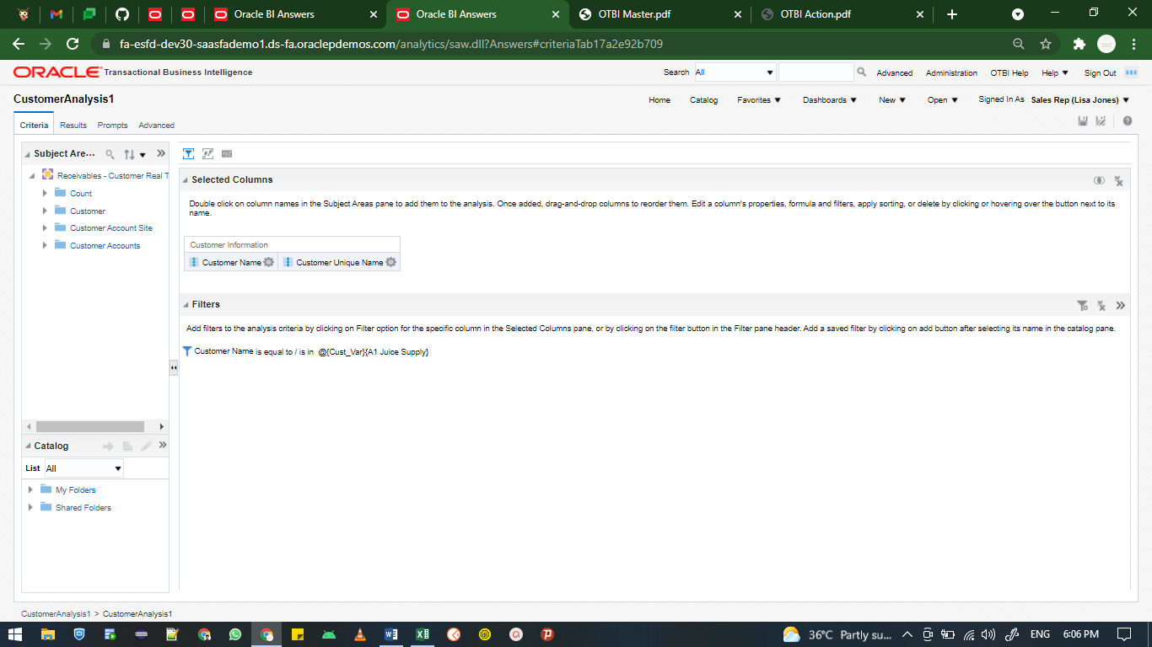

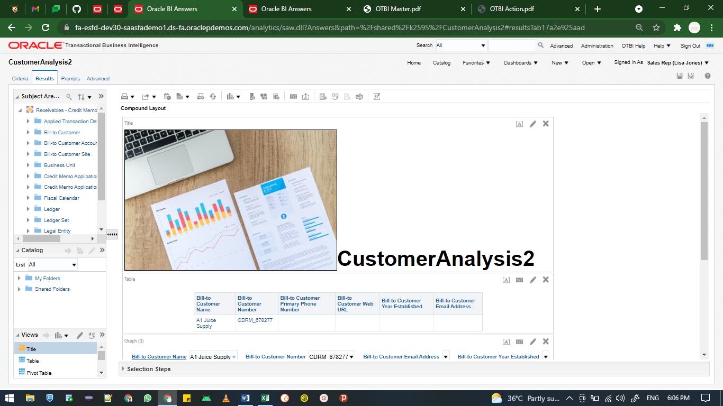

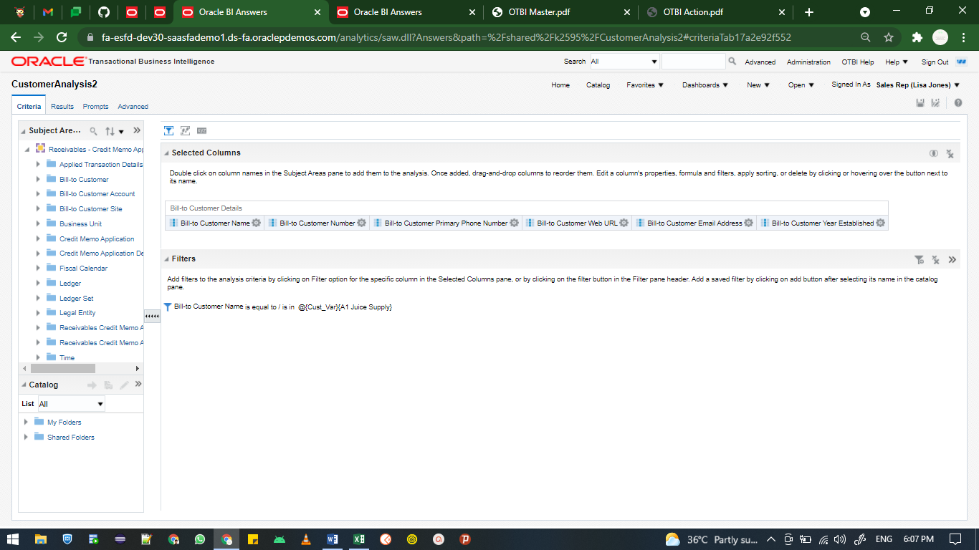

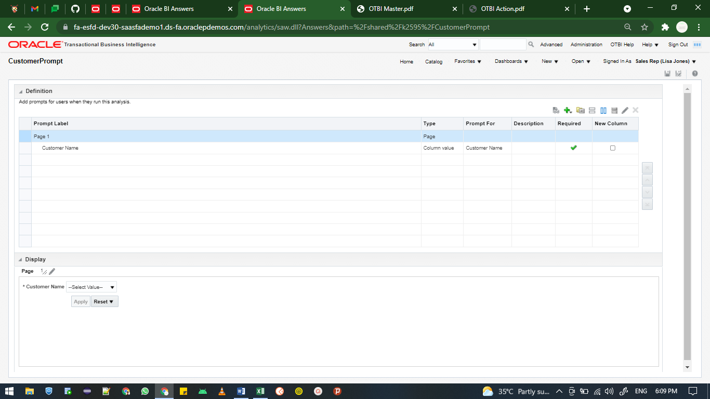

1. **MASTER LINKS:**

Steps Involved in Action Link

● Click New==>Analysis

● In subject area choose you module like Payables, Receivable, Suppliers etc.

● Choose the Corresponding columns

● Then Create Master Event details ID/code

Column properties==>Interaction==>Value==>send master-event details

===>Specify channel (like MD001, MD005)

● Then Open another analysis and Link Master event code

● Must prompted the Master event created column

● At last put those two Analysis into Dashboard. Save and Run

**Click to open the files**

***Screenshots:***

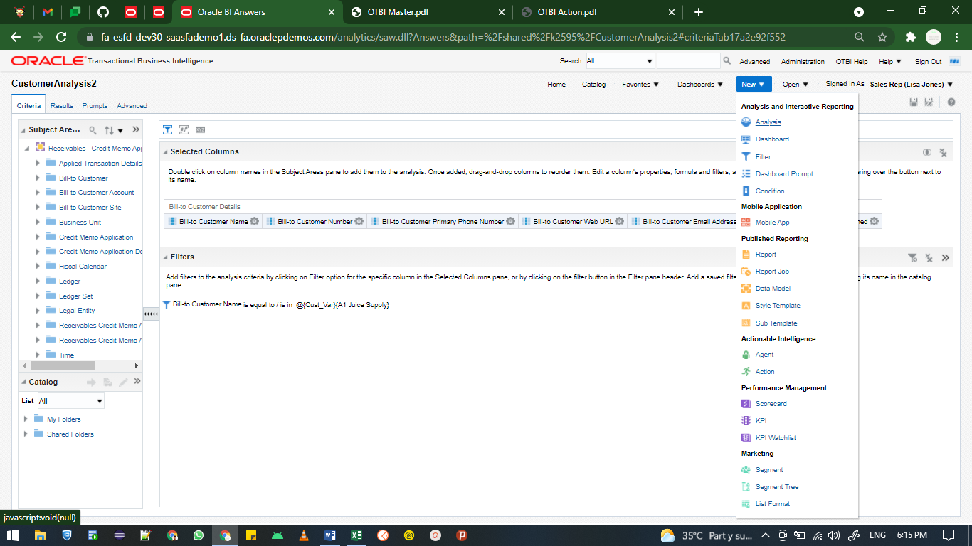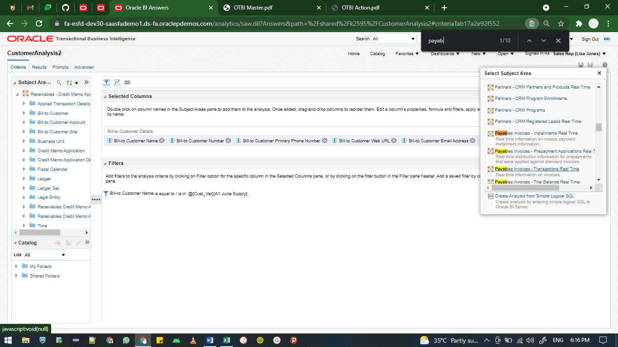

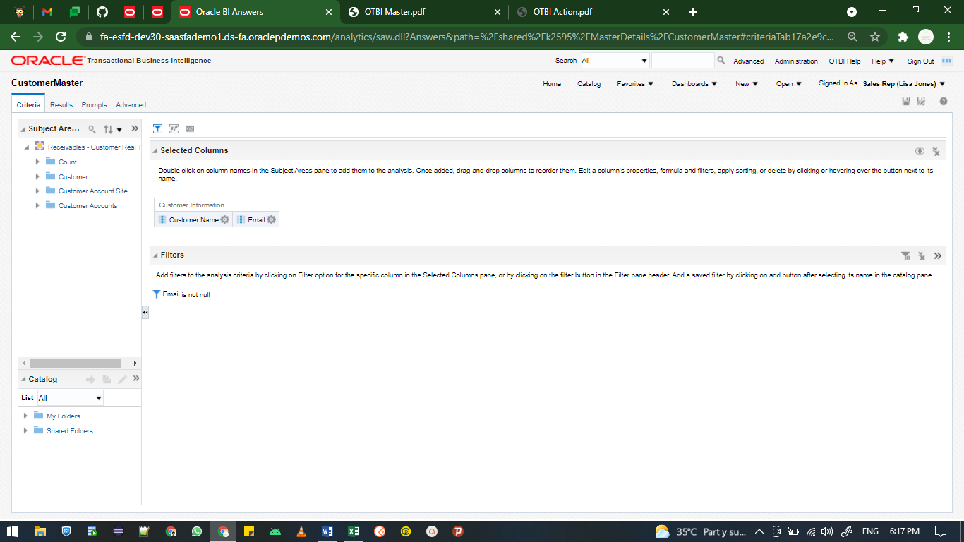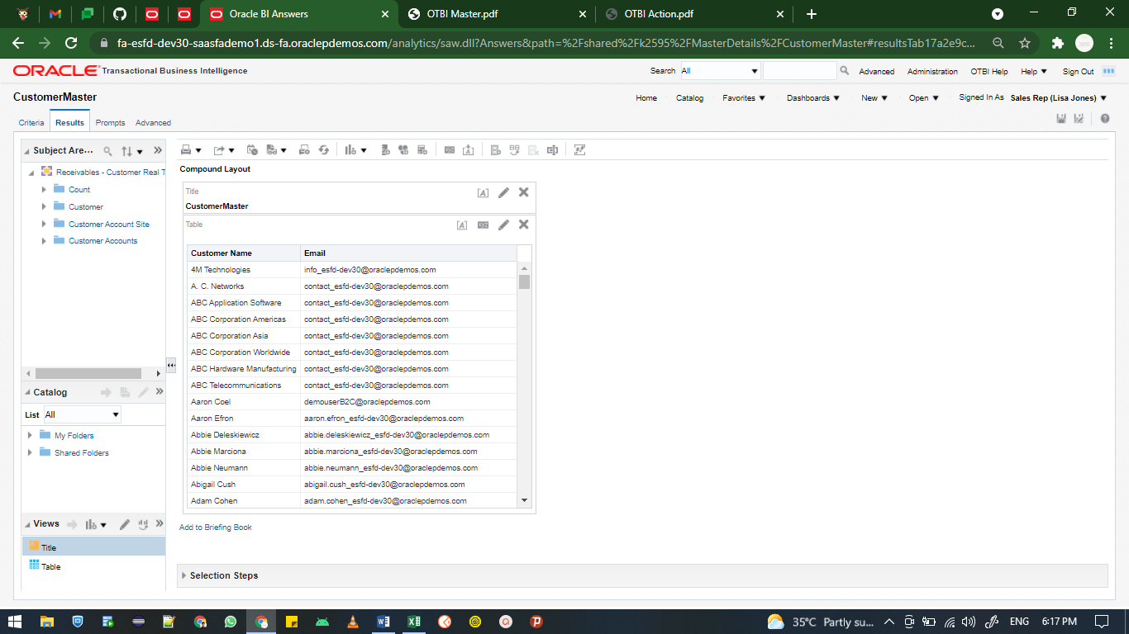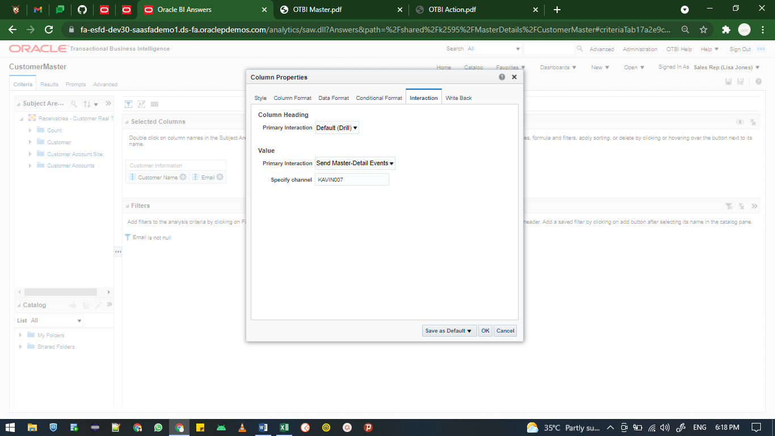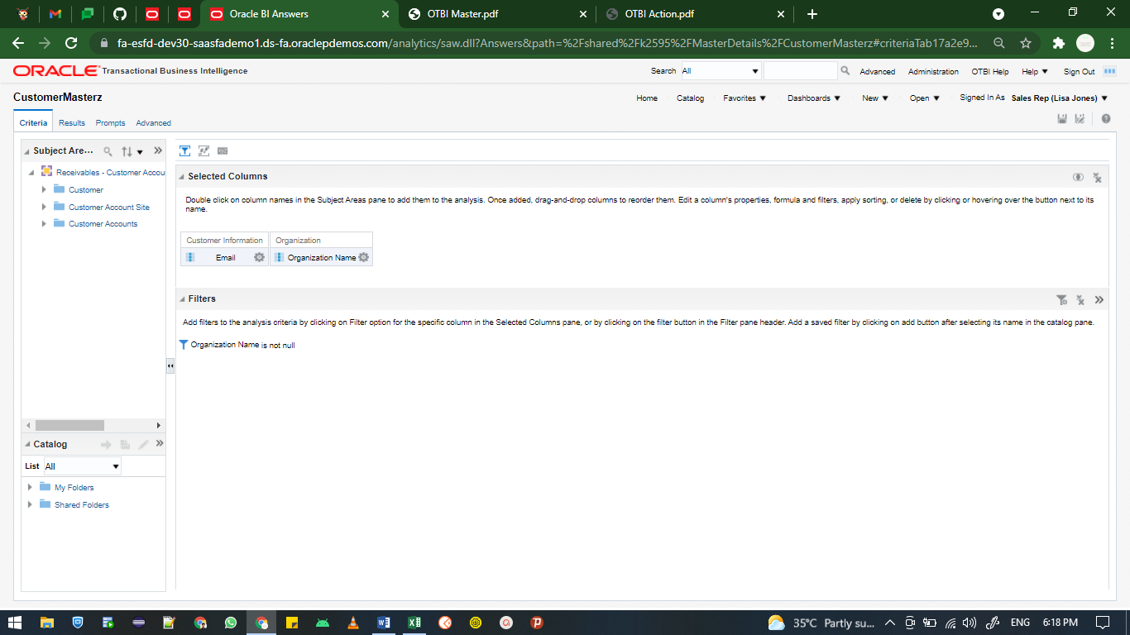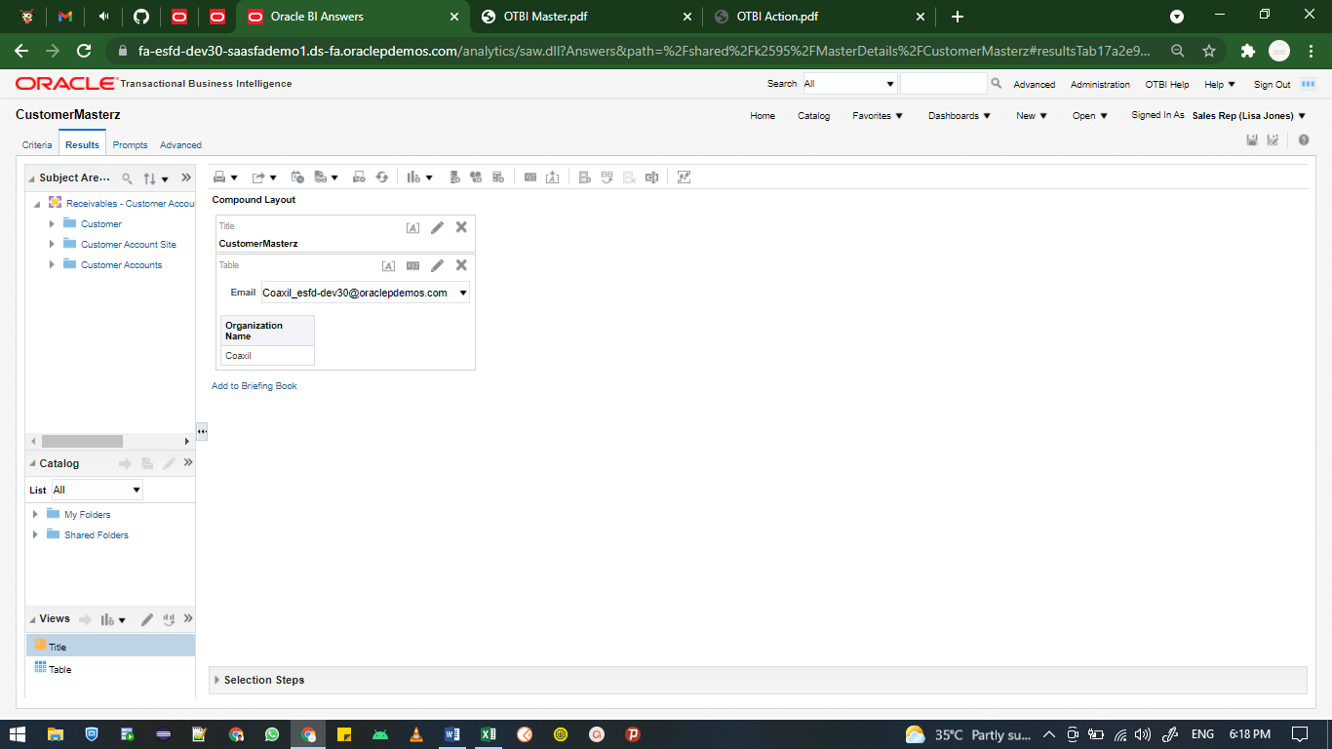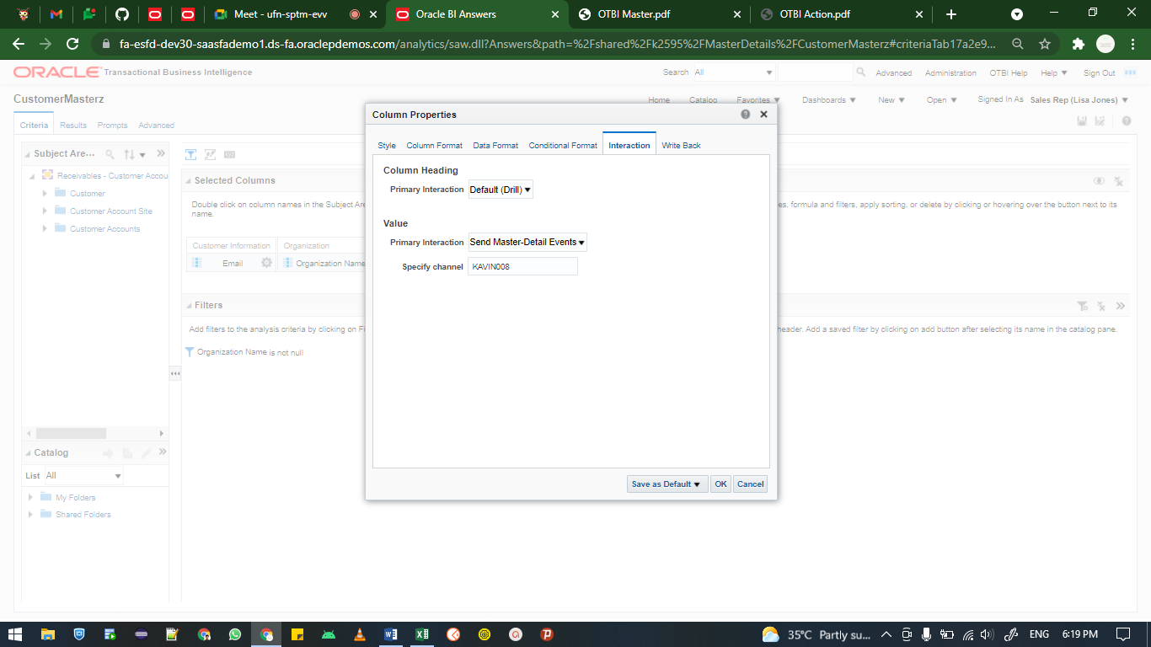

***Output:***

